Grace Nardei

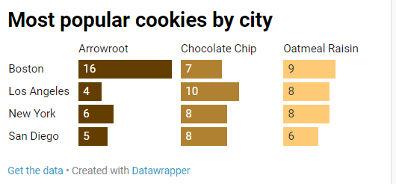

<https://datawrapper.dwcdn.net/d67GG/1/>

What does your city say about the kind of sweet tooth your fellow city goers have?

Arrowroot cookies are the most popular cookies are super popular in Boston. In, 2016, most orders for Breyers Arrowroot cookies went to the western part of the city for its annual Arrowroot cookie festival.

Chocolate chip cookies and oatmeal raisin cookies are fairly popular across the board.

**See work related data image down below**

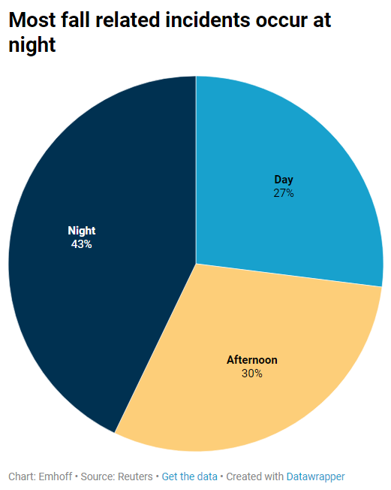

<https://datawrapper.dwcdn.net/YCpwv/1/>